

Activity: Arts and Crafts with tissue Objective(s): Decorating a Christmas ornament
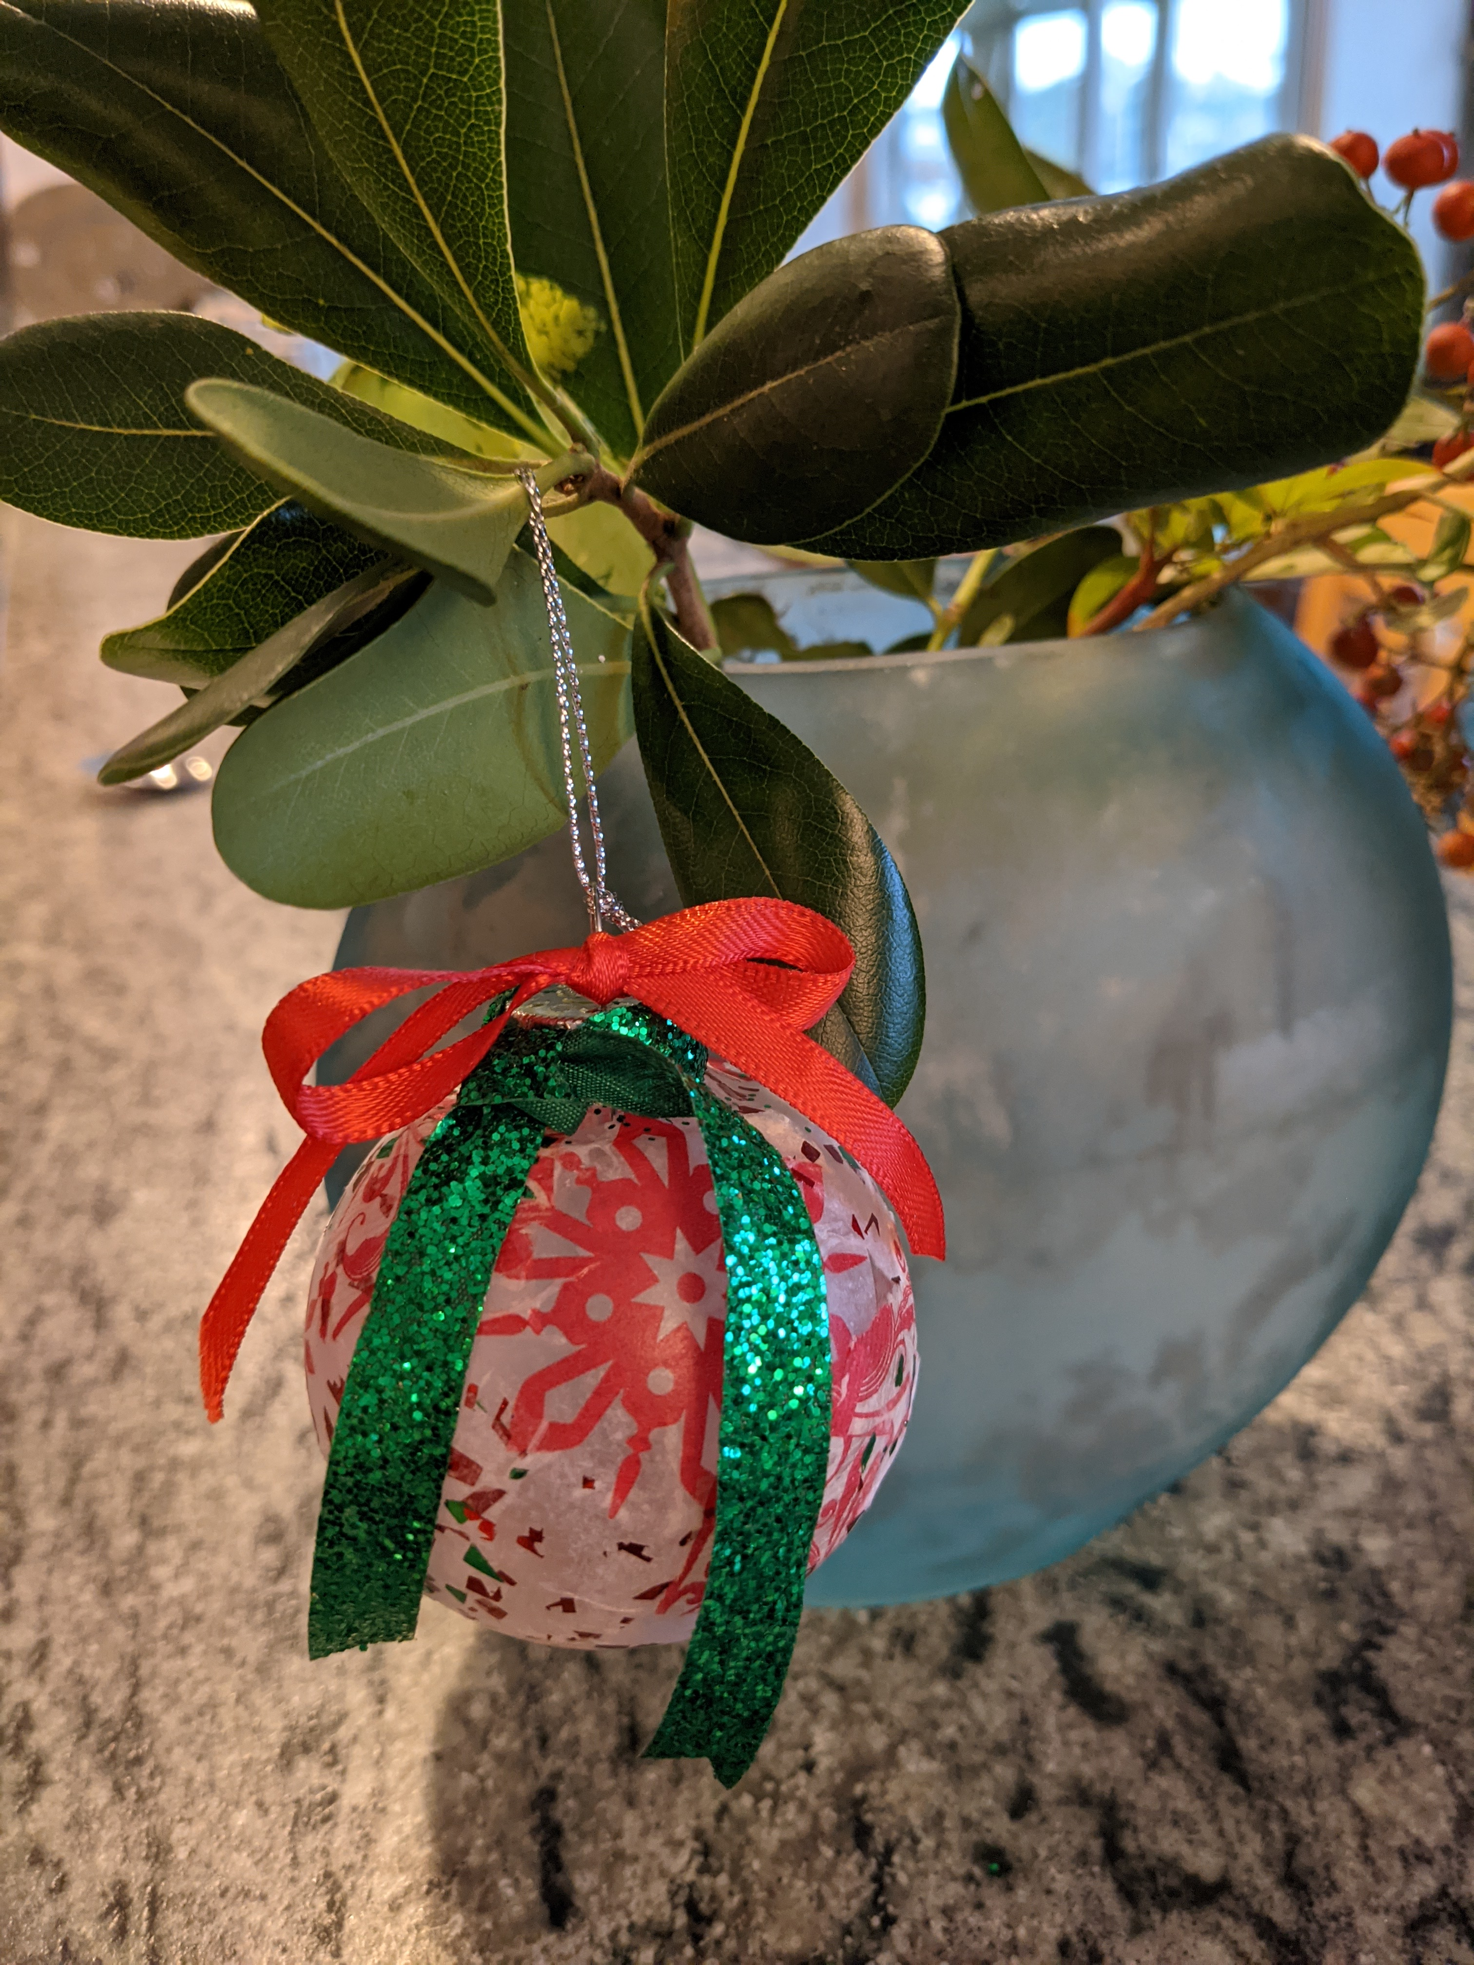

Choices: _ Arrange tissue, tie ribbons as desired

Equipment: You can use it again (scissors) | Supplies You use them up (glue) | Shopping list
Cardboard holder for ornament | Tissue pieces and extra strips to rip up if needed | White glue and applicator
 | Ribbon
 | Ornament (ball/pine cone)

Sequence, Steps and Tasks: Participants | Staff /volunteer help
- Mix small amount of white glue with water in a clear plastic cup, half glue and half water
- Dump out tissue pieces from ornament holder and set ornament inside (to keep it from rolling away!)
- Dab glue mixture on ornament, covering several inches.

- Choose tissue piece and apply to glued surface. You can apply more glue mixture as needed on top of the tissue. It dries clear.
- Continue steps 3 and 4 until entire surface is covered. It is fine to overlap pieces of tissue- it creates a lovely pattern.
- When ornament is mostly dry, tie ribbons around top of ornament, in bows or as streamers.
List tasks that went well:
List tasks that require tweaking:
What to change/How to improve?

